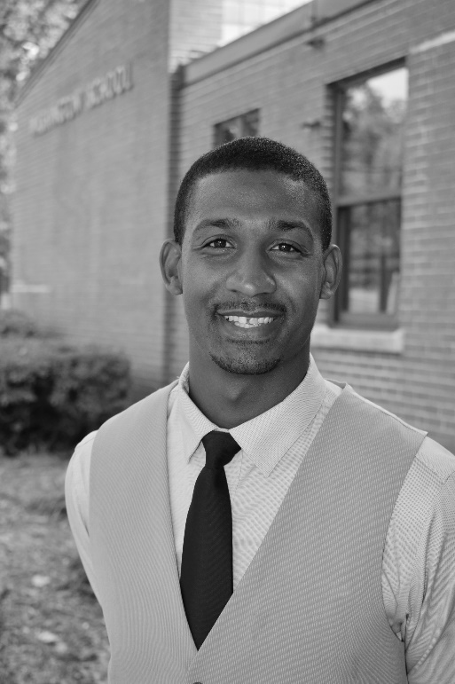
Greetings Washingtonians,

I have had the pleasure of serving as the principal of Washington Montessori Elementary School since July 2018. Prior to arriving at Washington, I served as assistant principal at Dudley High School and as an elementary school teacher at Jefferson, Foust, and Shadybrook Elementary throughout my 10-year career in education. I will continue to be dedicated to ensuring our students receive effective and equitable instruction while uniting the community and school.

I am committed to leading our staff in doing everything to the best of our ability every single day. In doing this, I am confident that we will ALL Honor our Community, Show our Excellence, and Think Critically!

In my free time, I enjoy running, doing woodwork, and spending time with my family.

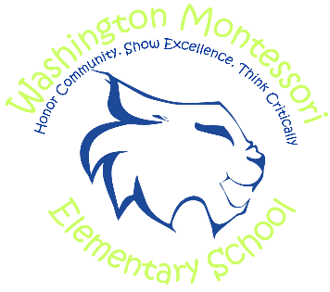
Please don’t hesitate to reach out to the school at 336.370.8290 if you need anything!

Paul Travers

